Year 12

Physical Education Studies

Exercise Physiology

Temperature Regulation

* Heat Gain
  + Hormones
  + Environment
  + Muscular Activity
  + Basal Metabolic Rate
* Heat Loss
  + Radiation
  + Convection
  + Conduction
  + Evaporation

Methods of Heat Transfer

Conduction

* + Transfer of heat between 2 objects in contact
  + Factors affecting:
    - Difference in temp between 2 surfaces
    - Surface area (increased surface area = increased heat loss)
    - Thermal conductivity of material
  + Plays a small role in regulation of temperature

Convection

* + Heat exchange by contact with a flowing fluid
  + Occurs when heat is carried away from body by air or water currents
  + Layer of warm air which continually surrounds our body is displaced by cold air lowering our skin temperature
  + Does not work if air is slow
  + Accounts for approx. 12% of heat loss

Radiation

* + Transfer of heat from a warmer body to the cooler surroundings without physical contact
  + Accounts for 60% of heat loss at rest on a cool day

Evaporation

* + The cooling of the body as a result of the vaporisation of sweat
  + Accounts for approx. 80% of heat loss in hot conditions
  + Does not work in humid conditions
  + Rate of sweating dependent on:
    - Gender
    - Number of sweat glands
    - Body surface area
    - How fit you are
  + Excessive sweating leads to drop in body fluids which increases body’s core temp

Factors effecting methods of heat transfer:

* Environment
* Age: children sweat less than adults as their sweat glands have not fully developed.
* Physiological State: Rate of heat production and Hydration state- reduction in blood plasma volume results in decreased sweat

Dehydration:

* Occurs when the amount of water leaving the body exceeds the amount that is being consumed.
* Water is lost through
* Sweating
* Breathing
* Urinating

Double Heat Load:

* Heat fron internal conditions and from external conditions
  + Metabolic heat created by working muscles
  + Environmental heat in hot conditions
* Creates competition for blood flow
  + Muscles and vital organs require blood flow to sustain energy metabolism
  + Skin blood flow required to transport heat out to environment to keep core temperature cool. This blood flow cannot deliver its oxygen to the working muscles, impacting on performance

Cardiac Drift:

* When exercising the body directs blood flow to the skin to increase evaporation.
* An increase in sweat rate leads to a decrease on blood plasma volume. Leading to CD
* Heart rate increases in an attempt to maintain Cardiac Output
* The increase in HR is relatively smaller than the decrease in SV leading to a reduced CO
* As a result, skin blood flow decreases and oxygen sent to working muscles is reduced placing strain on the body to maintain exercise levels
* These changes lead to an increased core temperature and lower performance levels.

Methods to help stay hydrated

* **Hyper hydrate**
* Consume 150-200ml every 15 minutes during exercises
* Wear loose fitting light coloured clothing to permit free circulation of air between the skin and the environment, promoting convection and evaporation from the skin
* Pre cool the core body temperature via a range of methods including:
  + Ice towels and vests
  + Immersion in cool water
  + Drinking a slushie
* Acclimatise
* Post exercise consume 1.5x the amount of fluids lost during exercise to replace nad replenish what was used.

Hyponatremia:

* An abnormally low concentration of sodium in the blood. .
* Occurs when one sweats excessively and what is lost is only replaced with water.
* Can affect brain and muscle function.
* Sports drinks assist with this.

Heat Acclimatisation

* Athletes who train in hot climates have a thermoregulatory advantage over athletes who train in cool climates when it comes to competing in hot weather
* How to acclimatise
  + 5-10 days living and training in heat
  + First sessions should last for 15-20 minutes
  + Should increase to 45-60 mins daily for 8-9 days with an increase in exercise intensity and duration
  + Artificial acclimatisation can be used
    - Climate chambers
    - Saunas
    - Sweat clothing
  + Should be completed 4-6 weeks prior to competition and then 2 times per week leading up to competition
* Adaptions
  + Sweating
    - Increased sweat rate
    - Sweating starts at lower core temperature
    - Sweat is more diluted and can be spread more effectively over the body – keeping salt in the body
  + Cardiovascular
    - Lower core and skin temperatures due to sweating adaptions
      * Lowers HR
      * Reduces body’s need to send blood to the skin for cooling, resulting in a greater % of cardiac output

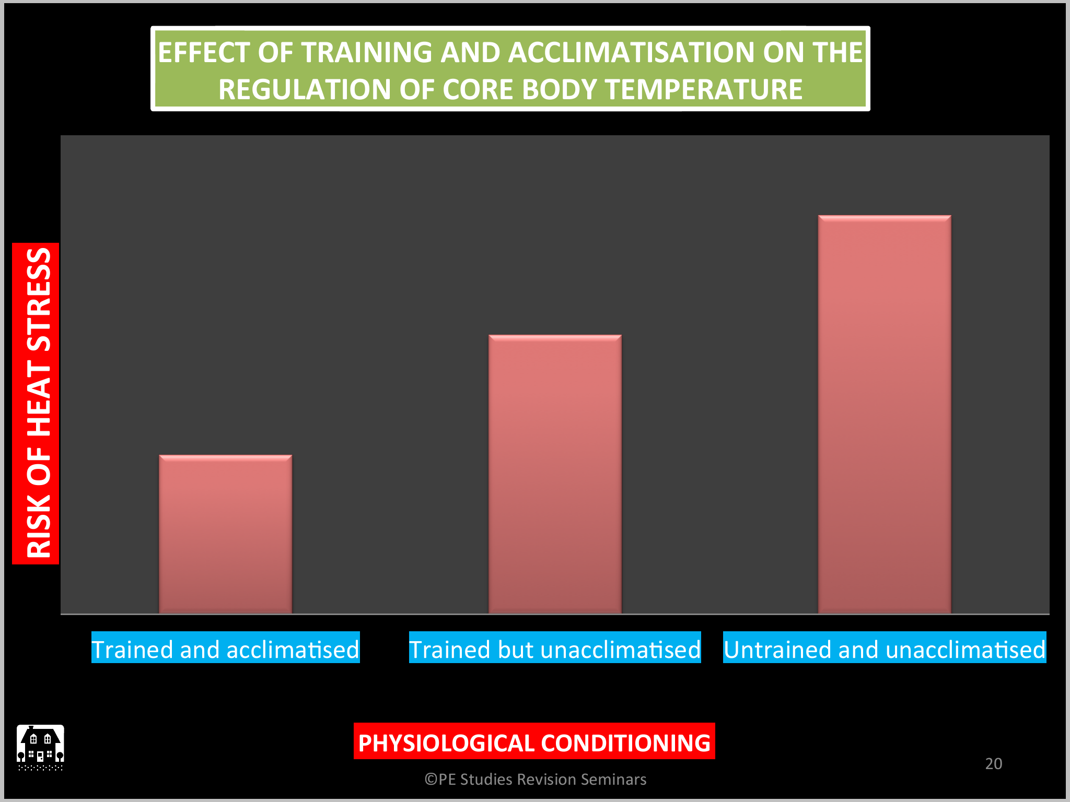

Humidity

* As temperature increases, along with humidity, the feeling of discomfort increases
* Heat index = scale as to how hot it feels

Performance in Cold weather

* Increase in submaximal VO2 at given exercise intensity
* Deterioration of fine motor skills due to vasoconstriction
* Risk of dehydration
  + Cold and dry air needs to be warmed and humidified resulting in loss of fluid via respiration
  + Reduced sense of thirst leads to reduced voluntary intake of fluids leads to mild dehydration

Risk of Dehydration:

* + - Inhaled air is very cold and dry- needs to be warmed, therefore lots of water used in this process
    - Reduced sensation if thirst, increases likelihood of dehydration

Hypothermia

* Occurs when body’s temperature falls below 35 degrees celcius
* Situations where this may occur include:
  + Prolonged exposure to cold, wintry conditions
  + Being in cold water for a length of time
  + Being out in windy weather in wet clothes

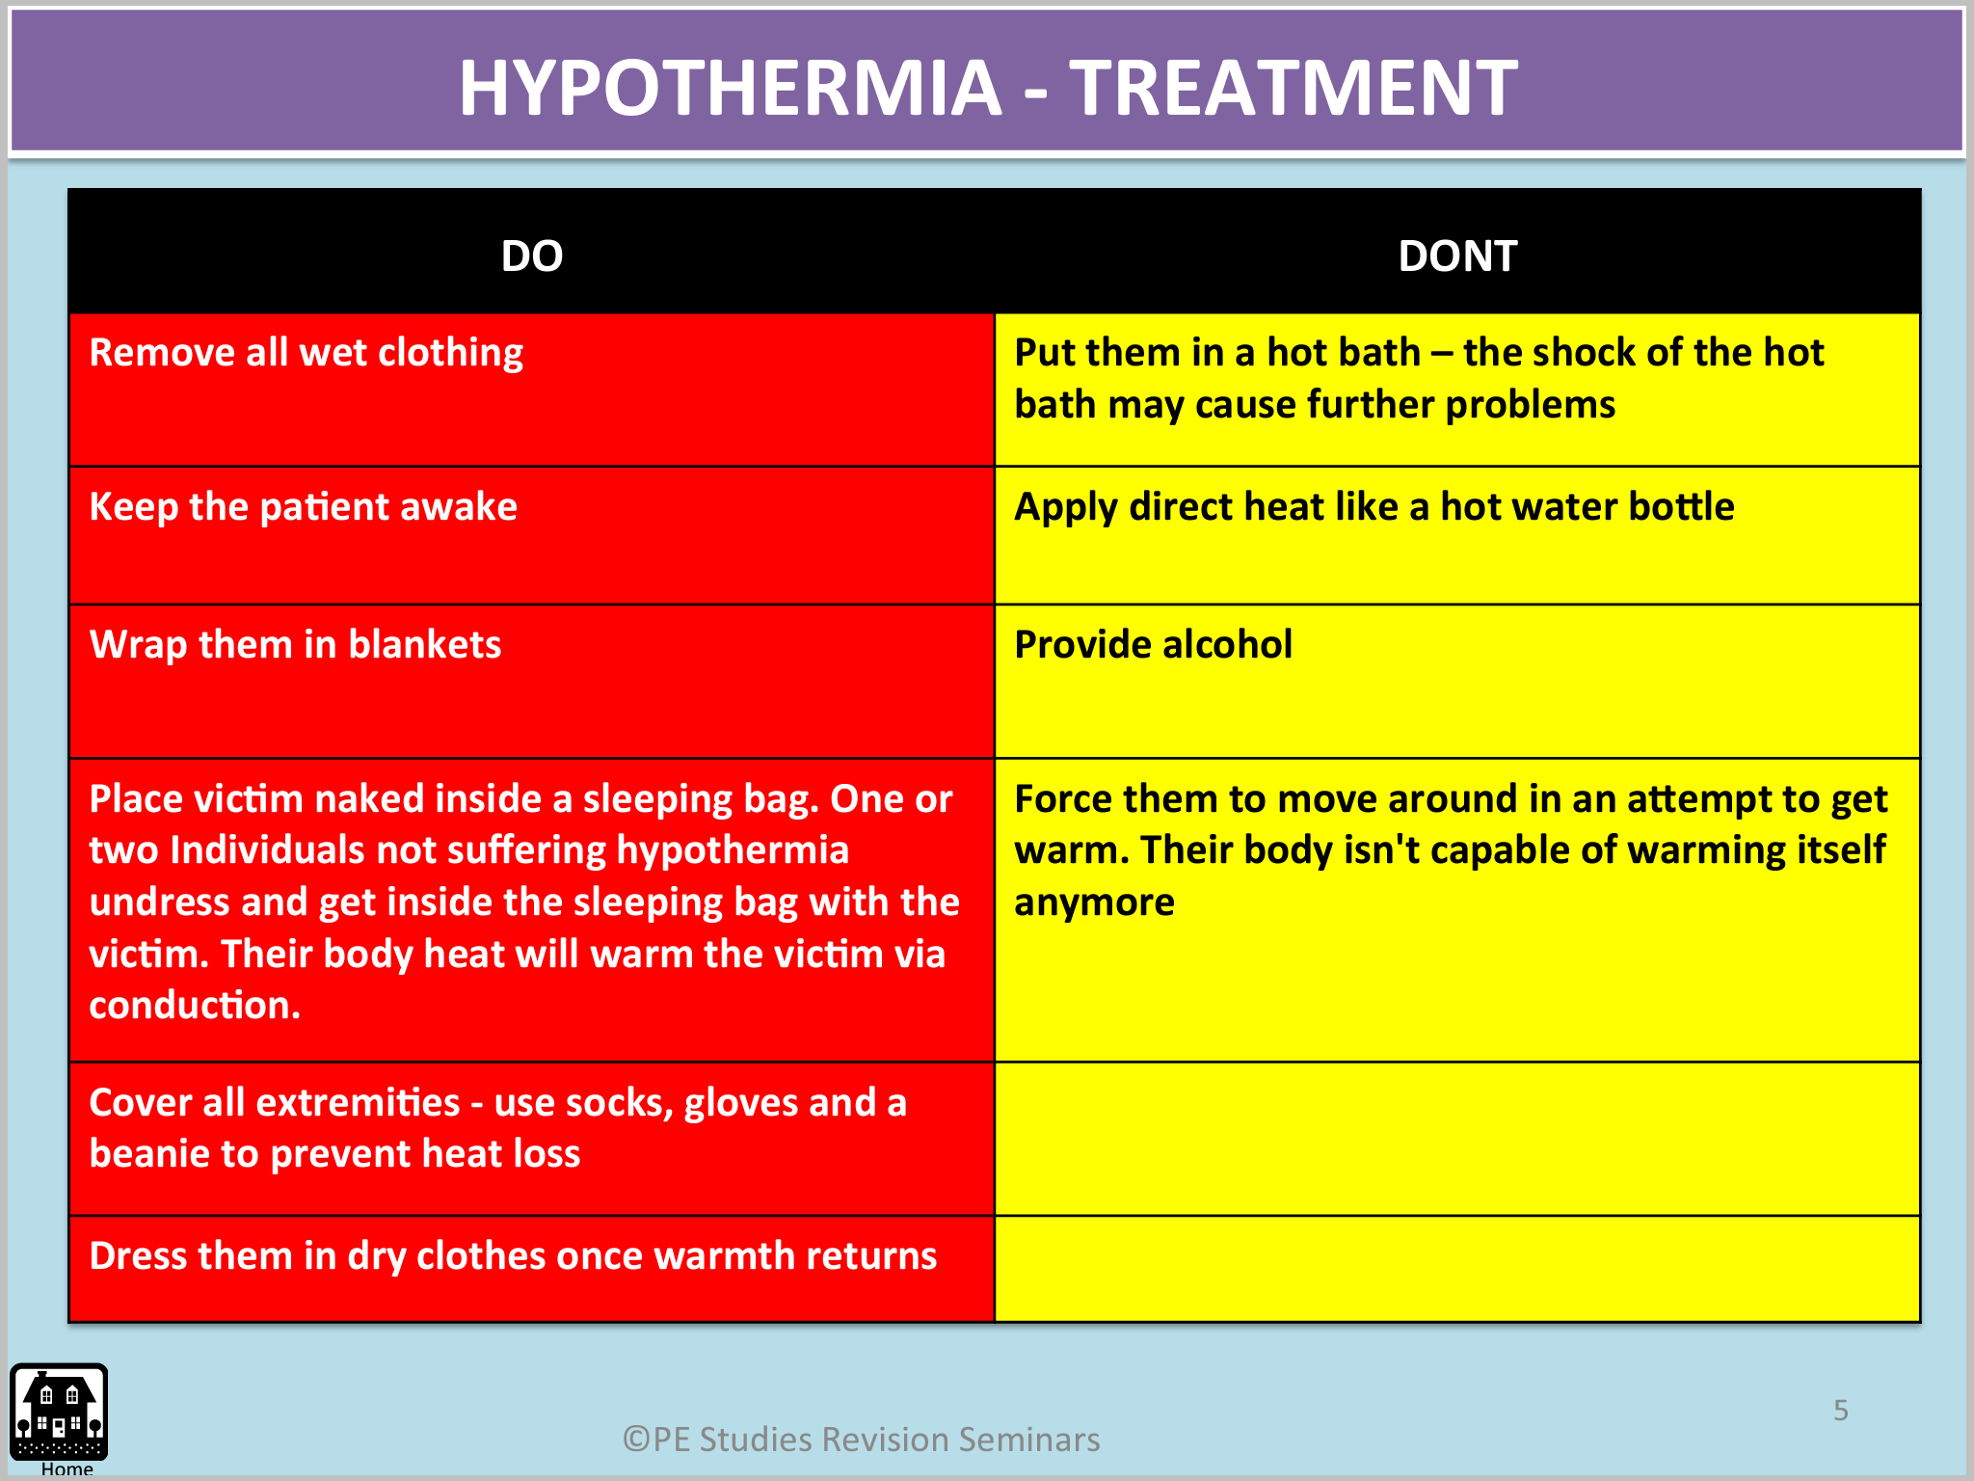

Cold Acclimatisation

* Less important than for exercise in heat
* 7-10 days prior to competition
  + Allows chance for experimentation clothing/warm up
  + Psychological adaptation
  + Athletes train their body systems to generate more heat and better prevent heat loss (possibly)
* There is no evidence to suggest that there are any physiological benefits, it is more psychological.

Altitude: Gas exchanges takes place due to a pressure difference, called a pressure gradient.

At altitude there is a reduction in this pressure gradient.

* Environment
  + Air contains
    - 20.93% Oxygen
    - 79.04% Nitrogen
    - 0.03% Carbon Dioxide
  + The more air above that point, the greater the barometric pressure
  + The higher above sea level, the lower the barometric pressure
    - At Mexico City, 2240m above sea evel, air has a barometric pressure of 585mmHg
    - At Mount Everest, 8848m above sea level, air has a barometric pressure of 231mmHg
  + Reduced barometric pressure allows for a reduction in the pressure of oygen entering the lungs = less oxygen enters lungs
* Gas exchange
  + Inhalation, O2 moves through the lungs and into the alveoli where it diffuses to the blood to be transported to the tissues
    - Gas exchange occurs due to a pressure gradient
      * High O2 in alveoli and low O2 in blood meaning that exchange occurs between the two
  + At altitude, pressure of O2 entering the lungs is reduced = a reduction in the pressure difference meaning less O2 diffuses from the alveoli to the blood

Altitude Acclimatisation

* Method 1
  + Daily intermittent exposure to artificial altitude environments
    - Hypoxic apartments, altitude houses and tents
  + Artificial chambers allow athletes to sleep in altitude induced environments whilst still training under normal conditions
* Method 2
  + Live high, train low
  + Altitude camps 2 times a year
  + Require 3-4 weeks of training at altitude to allow adaptations at kevek around 2000-3000m above sea level
  + Significant financial and practical hurdles

Acute Adaptations of Altitude Acclimatisation

1. Increased pulmonary ventilation
2. Increased Heart Rate and Cardiac Output during rest and at submaximal exercise
3. Decrease plasma volume to increase concentration of haemoglobin in the body

Chronic Adaptations

1. Increased haematocrit (% of RBC)
   1. Cause haemoglobin concentration to increase
2. Increased mitochondria, aerobic enzymes, capillaries, myoglobin
3. Increased 2,3 DPG which helps in the unloading of oxygen (diphosphate glycerate)

Returning to Sea Level

* Within 7 days
  + Hyperventilation disappears
* After 2-4 weeks
  + Haemoglobin and haematocrit levels return to normal
  + Increased mitochondria, capillary and enzyme levels though to last longer provided training is maintained

Preparing for Competition at Altitude

* Increase recovery between sessions is required following exercises bouts at altitude
* An extended tapering period in the lead up to major competition is required to enable the athlete time to peak
* Training intensity at altitude must be decreased given the strenuous nature of the conditions
* A strict fluid replacement regime needs to be put in place as less humid conditions create a greater risk of dehydration

Pollution

* Ozone
  + Affects respiratory function and may cause permanent damage to alveoli if exposure occurs over long period of time with high concentrations
    - Reduces endurance performance with VO2 max levels lower at high concentrations
* Carbon Monoxide
  + 200 – 250 times more likely to bind with haemoglobin than oxygen
    - Reduces oxygen carrying capacity in the blood is reduced
      * Reduces VO2 max
      * Sub maximal HR increases
      * Endurance performances reduced

Jet Lag

* Athletes all over the world often have to deal with the effects of air travel and changing time zones
* Circadian rhythms are out body’s natural 24hr cycles that control appetite, energy, mood and sleep

How to counter the effects of Jet Lag

* Arrive at least 1 day early for each time zone crossed
* Adjust your eating and sleeping patterns to match those of your new destination
* Eat and drink frequently before, during, and after travel

Nutrition

* The amount of energy people consume is dependent on a number of factors:
  + Age
  + Sex
  + Level of physical activity
  + Periods of growth
* For a normal male:
  + 55-60% carbohydrates
  + 25-30% fat
  + 10-15% protein
* Athletes involved in heavy endurance
  + 70% carbohydrates
  + 15% fats
  + 15% protein (possibly 30 for body builders)

Protein

* Functions:
  + Repair muscle fibres
  + Growth of muscle fibres
  + Constructs RBC, hormones and antibodies
  + Can be used as a source of energy when carbohydrate and fat stores are completed

Fats or Lipids

* Represents body’s most plentiful source of potential energy
* Fats (triglycerides in muscle cells to be broken down into fatty acids) are the major energy source during rest and light to moderate exercise with little input during intense exercise
  + Trained athletes break down fats faster

Carbohydrates

* When ingested
  + CHO converts to blood glucose which leads to an increase in insulin
  + Excess blood glucose is converted to glycogen

Glycemic Index

* Ranking of carbohydrates based on their immediate effect on blood glucose levels

High GI

* Break down quickly during digestion therefore having an immediate effect on increasing blood sugar levels
* Best consumed during and immediately after the event
* EXAMPLES
  + Honey
  + White bread
  + White rice
  + Banana

Low GI

* Break down slowly during digestion – releases glucose gradually into the blood stream
* Best consumed as part of the pre-event meal and after the event to replenish glycogen stores
* EXAMPLES
  + Apples
  + Lentils
  + Kidney beans
  + Peanuts
  + Navy beans
  + Sausages

Fuelling energy systems

* Low intensity exercise uses triglycerides as the main energy source
* As intensity increases muscle glycogen is used more and more
  + When muscle glycogen runs out, liver glycogen is used
* Depletion of liver glycogen = bonking
* Fats now become the primary fuel source and intensity of exercise is reduced as fats are now more difficult to break down
* Depletion of fats results in protein being used as an energy source

Hydration

* The body loses water through
  + Breathing
  + Sweating
  + Urinating
* To ensure the body does not become dehydrated, 2L of fluids/day are recommended
* Determining hydration levels
  + Urine test
* For optimal hydration:
  + Hyperhydration Pre Exercise
    - 1L prior to exercise recommended
    - 300-400ml just prior on top of 600ml 3-4 hours before
  + During Exercise
    - Approx 200ml of water every 15min
    - Average sweat rate in endurance activities is 1-1.5L/hour
    - Don’t drink when you are thirsty
    - Avoid drinking just water as salt lost in sweat needs to be replaced
  + Post Exercise
    - Want to replenish back to pre exercise weight
    - For every 1L lost consume 1.5L
    - Consume slightly salty fluid to keep osmolality higher

Pre-Event Meal

* Considerations
  + Preferences
  + Low in fat and fibre
* Advantages
  + Increase glycogen levels leading to glycogen sparing
  + Ensure optimal hydration
  + Ensure gasto-intestinal tract feels comfortable during performance
* Consume 1-4 hours prior to competition and low GI foods for the slow release of glucose into blood stream

During the Event meal

* CHO consumption is important to avoid depletion
  + Also prevents low blood sugar levels
  + Prevents CNS inhibition and feeling of fatigue
* Consume 30-60g of high GI CHO per hour

Recovery Meal

* Immediately following exercise, muscles are most responsive to high GI foods to replenish glycogen stores

LEGAL AND ILLEGAL PERFORMANCE ENHANCEMENT STRATEGIES

Ergocenic Aids

Any practice or substance used to improve performance. May include practices such as the use of heart rate monitors or nutritional aids or illegal aids such as the use of anabolic steroids

1. Physiological
2. Nutritional
3. Mechanical
4. Pharmacological
5. Psychological

Illegal Ergogenic Aids

* Anabolic Steroids
  + Increase size and strength through facilitation of muscle development
  + Major benefit in sports requesting strength and power
  + Side effects include
    - Acne
    - Liver damage
    - Depression
    - Aggression
    - Hypertension
    - Infertility
* Human Growth Hormone (HGH)
  + Increase muscle mass
  + Increase strength
  + Burn fat
  + Harder to detect than anabolic steroids
  + Side effects
    - Acromegaly
    - Enlargement of heart
    - Hypoglycaemia
    - Swelling of the brain
* Diuretics
  + Increases volume of urine
  + Used to make weight
  + May be used as a masking agent by diluting the concentration of illegal substances
  + Side effects
    - Weakness or dizziness
    - Muscle cramps
    - Diarrhoea
    - Joint Pain
* Beta Blockers
  + Decrease heart rate
  + Decrease muscle tremors
  + Decrease pre-competition tremors
  + Side effects:
    - Drowsiness or fatigue
    - Hypotension
    - Shortness of breath or trouble breathing
    - Weakness or dizziness
* Stimulants (amphetamines, cocaine, pseudoephedrine)
  + Increase awareness
  + Increase aggression
  + Masks fatigue 🡪 improved anabolic performance
  + Side effects
    - Anxiety
    - Restlessness
    - Insomnia
    - Dependence
    - Ineffective heat regulation
    - Dehydration
* Narcotic Analgesics (codeine, morphine, opiates)
  + Mask pain
  + Allow performer to continue to perform despite injury
  + Side effects
    - Dependence
    - Drowsiness or light headedness
    - False sense of well being
* Blood Doping
  + Remove 1L of blood prior to event
  + Blood separated into plasma and RBC’s
    - Plasma injected back into body
    - RBC frozen for storage
  + Body naturally restores the removed RBC’s through secretion of EPO over time
  + Just prior to competition, frozen RBC’s added to the body through transfusion
    - Increases RBC’s therefore
      * Increase oxygen carrying capacity
      * VO2 max increase by 20-25%
  + Risks
    - Transfer of blood born diseases
    - Blood clots
    - Stroke and heart failure
* Erythropoietin
  + Injecting EPO (a naturally created hormone) increases the rate of manufacture of RBC’s
    - Increases oxygen carrying capacity
    - Improves VO2 Max
  + Thickens the blood increasing the chances of
    - Blood clots
    - Strokes
    - Heart failure

High Carbohydrate Powders

* Used to carb load or refuel after exercise
* Examples include
  + Polyjoule
  + Polycose

Carb Loading:

* + - * + Is a nutritional intervention aimed at delaying the depletion of glycogen stores. It occurs when the athlete increases the amount of CHO consumed prior to competition with the aim being to store extra glycogen in the liver and muscles
        + As exercise increase, the amount of CHO used increases
        + Muscle and liver glycogen, and blood glucose can be used within 2 hours, so CHO loading assists with the prolonging of this
* 3 Day Method
  + Consume approximately 7-8g/kg bodyweight of carbs for 3 days leading to competition
  + Players can still exercise by minimally
* 1 Day Method
  + Consume approximately 8-10/kg bodyweight of carbs for 3 days leading to competition
  + Tapering or reducing necessary
* 85% of O2 max = 90% of energy from CHO
* Muscular glycogen, liver glycogen and blood glucose can be depleted in 1.5-2 hours
* Advantages
  + Avoids depletion of glycogen stores
  + Allows aerobic athletes to maintain a higher intensity for a longer period of time
* Disadvantages
  + Binding of CHO with H2O increases water absorption causing an increase in weight
* Carb supplements
  + Polycose and Polyjoule
    - 94-95% concentration
  + Lucozade
    - Not as much as polycose and polyjoule

Rebound Hypoglycaemia:

* When an athlete consumes High GI food just prior to an event, causing a rapid increase in blood glucose levels and an overshoot of insulin release
* This significantly reduces blood sugar levels, Impairing the functioning of CNS during exercise
* This results in a decreased performance

Creatine

* Obtained via consumption of meat, poultry and fish
* Available as powder, tablet, capsule or liquid
* Advantages
  + Increase PCr stores by up to 25%
    - Allows athletes to train more
  + Improves ATP and PCr resynthesis in recovery
    - Improves athlete’s ability to produce repeated efforts leading to increase training benefits
  + Increase in PCr stores in muscle means that ATP/PC system can work longer before anaerobic glycolysis takes over preventing the muscle inhibiting hydrogen ions
* Disadvantages
  + Cramping
  + Gastrointestinal pain
  + Reduces body’s own ability to make creatine leading to dependence
  + Increases the storage of water in the muscle

Sports Drinks

* Flavoured drinks that rapidly deliver duel and fluids when digested
* Contain 6-8% CHO and are designed for fast absorbance during and after performance
* Advantages
  + Taste good
  + Work to hydrate you and give your body an immediate source of energy
  + Sodium provides more absorption of fluid and retention of fluid

Glycerol

* 3 Carbon molecule naturally occurring in the body
* When ingested, it is absorbed and increases the concentration of of the fluid in the blood and tissues
  + Allows body to retain extra fluid temporarily
* Most effective in moderate to high intensity exercises in the heat when fluid intake can’t match fluid loss during exercise
* Effective in rehydrating quickly following ‘making weight’
* Side effects
  + Headaches
  + Gastrointestinal problems
  + Weight gain

Caffeine

* For maximum benefits, 3-6mg/kg of body mass is consumed prior to competition
* Advantages
  + Reduces perception of effort 🡪 increases time to exhaustion in short distance events
  + Stimulates the CNS 🡪 increasing alertness, reaction times and arousal levels
  + Possible glycogen sparing effect through the oxidation of free fatty acids
* Disadvantages
  + Diuretics
  + Irritability
  + Insomnia
  + Headaches
  + Muscle twitching
  + Withdrawal effects
  + Excessive intake may lead to over arousal

Bicarbonate

* Buffers against the build up of H+ ions and lactate which have a fatiguing effect when working anaerobically
* Consumed as powder
* Take approx. 300mg/kg body mass 60-90min prior to exercise
* Advantages
  + Acts to increase resting pH levels
    - A decrease in pH levels during high intensity exercise negatively affects a performance through impaired muscular contractions
    - Consumption of bicarbonate pre exercise delays the build up of H ions, inhibiting the effects of acidosis during intense activity
  + Disadvantages
    - Diarrhoea
    - Muscle spasms
    - Gastro-intestinal cramping
    - Irritability
    - Vomiting

Vitamin and Mineral supplements

* Ensures adequate vitamin/mineral levels

Sports Bars

* Low in fat and fibre whilst providing a source of protein and CHO
* Fuel during and after exercise – should be consumed with fluids
* Not as effective for preloading
  + Not enough CHO

Gels

* Concentrated form of CHO (60-70%)
* Most effective for endurance athletes during and post exercise
* Should always be consumed with fluid
* Advantage of being easily carried by an athlete

Liquid Meal Supplements

* Low fat powder or liquid mixed with water or milk
* Approx 50-70% CHO, 15-20% Protein, low to moderate levels of fat
* Used as meal replacement, liquid pre game meal, carbohydrate supplement
  + East to consume
  + Help refuel glycogen and protein stores

Iron

* Iron deficiency in blood can lead to anaemia
* Symptoms
  + Fatigue
  + Lifeless
  + Susceptible to Infection
* Sources
  + Meat, cereals and vegetables
  + Iron supplements

Building strength and bulk

* Requires a high energy diet in conjunction with a well planned resistance training program
* To gain strength and bulk:
  + Eat 5-6 times a day
  + Carbs and protein most important
  + All food and drink should be low fat
  + Creatine supplements may be beneficial to help with extra training benefits
* Pre season
  + 1.2-2g/kg of body weight of protein
  + 6-8g/kg og bodyweigh of CHO
* In Season
  + Training volume decreases
  + Resistance training decreases as skill training increases
  + Carb and protein intake reduced early in the week and increases carbohydrate intake later in the week

Measuring Change

* Beep test
* Agility test
* Strength tests

TRAINING PROGRAMMES

Periodisation of Physical Skills training

* Involves varying the volume and intensity of training and if done properly it will
  + Promote higher levels of enthusiasm
  + Avoid staleness
  + Ensures proper application of progressive overload
  + Minimises likelihood of injuries
  + Improves psychological, physiological, technical and tactical levels of players
  + Helps to peak at the right time
  + Plans for rest/recovery periods
* Annual plan is broken into phases
  + Preseason/Preparation
  + Competition
  + Evaluation
  + Off Season/Transition
* 4 phases 🡪 ocycles 🡪 mesocycles (4-12 weeks long) 🡪 microcycles (3-10 days long)

Preparation Phase

* Usually last 6-12 weeks
* General
  + Training designed to improve aerobic base
    - High training volume, low intensity
      * Continuous, interval, fartlek, flexibility
  + Fitness tests to gather baselines
* Specific
  + Game specific
  + Lower volume, higher intensity
    - HIIT
    - Weights
    - Pylometrics
    - Agility

Competition Phase

* Training for match specific skills
* Fitness is maintained
* Recovery sessions implemented and are critical
* Constant peaking and tapering are critical in allowing players sufficient recovery during the season

Evaluation Phase

* Analysis of strengths and weaknesses of the programme to determine what worked and what did not
  + Questionnaires, checklists, qualitative data
* Coaches need to determine whether skills introduced were beneficial to the performer

Transition/Off-Season Phase

* Volume and intensity decreased to allow for physical and psychological recovery
* Aerobic fitness should be maintained
* Nutrition should be monitored to ensure a return to active participation close to playing weight
* Opportunity for surgery and rehab
* Specialised programs to correct structural or skill deficiencies

Tapering

* The decrease in volume of training whilst maintaining or increasing intensity an athlete does to allow the body time to recover from the stresses placed on them during training
  + Physically allow the tissue damaged during training to be repaired and for the body to be refuelled
  + Mentally allows athlete to reach their ideal performance state (IPS)
* Done after a block of hard training or leading into a major competition
* Usually last between 4-28 days
  + Marathon = long taper
  + Sprinter = short taper

Strategies used to taper include:

* Reduce training volume and maintain or increase training intensity
* Increase the use of recovery techniques
* Monitoring diet to ensure athlete has adequate glycogen stores
* Individualise the program to ensure athletes needs are met

Peaking

* The term used to describe a temporary training state which allows the athlete to perform at their optimal level
  + Peaking at key times is a result of a well thought out annual plan
  + Peaked players are “IN THE ZONE”
* Obtaining IPS requires an individualised approach and keeping a journal can help players get into this state more often
* Should consider emotional, mental and physical characteristics
* Performer may see a particular trend developing which helps them to get into the IPS which may help them replicate that for each performance

Recovery

* Physically, it is required to overcome the fatigue, repair body tissue, replenish energy stores
* Psychologically it is needed to allow the athlete to enter the next contest or activity in an optimal mental state
* Includes
  + Nutritional recovery
    - The body’s energy stores are refuelled by consuming high carbohydrate foods and isotonic drinks
    - Protein for muscle tissue repair
  + Physical recovery
    - Regenerates the physiological capabilities of the athletes
      * Eg. hydrotherapy, sports massage, stretching, hyperbaric oxygen therapy, rest
  + Psychological recovery
    - Aimed at returning the athlete to an optimal mental state
    - Psychological recovery starts immediately after the game with a debriefing

Physical Recovery

1. Cool down (active recovery)
2. Replenishment of Glycogen Stores
3. Replenishment of fluids and electrolytes
4. Rest
5. Hydrotherapy
6. Massage
7. Hyperbaric Oxygen Therapy
8. Recovery clothing

Monitoring Recovery

* Training logs are used to monitor what is done at training
* Lab testing
* Observation
* Questionaires

Overtraining

* Occurs when an athlete has been repeatedly stressed by training to the point where the rest periods between sessions are no longer adequate for recovery to occur
* Training no longer leads to performance improvement
* Imbalance between work and rest
* Common in young athletes who are training for several teams
* Signs and symptoms carry but the most common is fatigue
* Common causes
  + High workload
  + Lack of variety
  + Insufficient recovery
  + Too many competitions
  + Incorrect application of progressive overload
  + Insufficient recovery methods, or lack of, leading to imbalance between rest, training and competition
* Prevention
  + Well planned training programme
  + Regular rest
  + Administer psychological tests
  + Educate players and coaches on signs and symptoms
  + Individual training program
  + Variety
  + Train at different venues
  + Keep well hydrated
  + Reduce training load or even stop training
  + Balanced diet

Maintenance

* During preseason, the body is overloaded in an attempt to
  + Develop an aerobic base
  + Increase strength
  + Increase speed and agility
  + Increase power
* During the season, it is important athletes maintain these fitness levels whilst increasing recovery. Achieved by
  + Reducing volume and increasing or maintaining intensity of training

DRSABCD

* Danger
* Response
* Send for Help
* Airway
* Breathing
* Compressions
* Defibliration

STOP

* Stop
* Talk
* Observe
* Prevent Further Injury

TOTAPS

* Talk
* Observe
* Touch
* Active Movement
  + Ask the athlete to move the injured part through full range of movement
* Passive Movement
  + Carefully try to move the injured part yourself through its full range of motion only to point of pain
* Skills Test

RICER:

* Rest
* Ice
* Compression
* Elevate
* Referral

HARM (Things to avoid)

* Heat
* Alcohol
* Running
* Massage

Rehab of the Injured Athletes

1. Range of Motion
   1. Should be improved until 80%-90% of pre-injury, pain free range of movement has returned
2. Endurance
   1. Exercise is completed with weight or resistance increasing when exercise becomes easy
3. Strength
   1. Increase weight or resistance so only sets of 10-12 reps can be completed
4. Skill
   1. Re-educate muscles to perform specific movements for their specific sport
   2. Requisite skills must be performed until the athlete can perform at pre-injury standard